**Week 2 – Hands-on : SL4J Logging Exercises**

Exercise 1 : Logging Error messages and Warning Levels

First we add dependencies, SLF4J and Logback, I have used version 2.0.9 for SLF4J and version 1.5.13 for Logback because the given version in workbook is flagged vulnerable by IntelliJ.

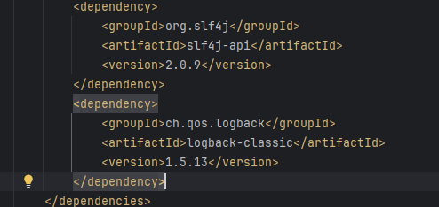

Then we create a new test class “LoggingTestExercise.java” in this we simulate a warning message and a Error message (I have used common division by zero error). This messages are logged and shown in output console.

**SOLUTION :**

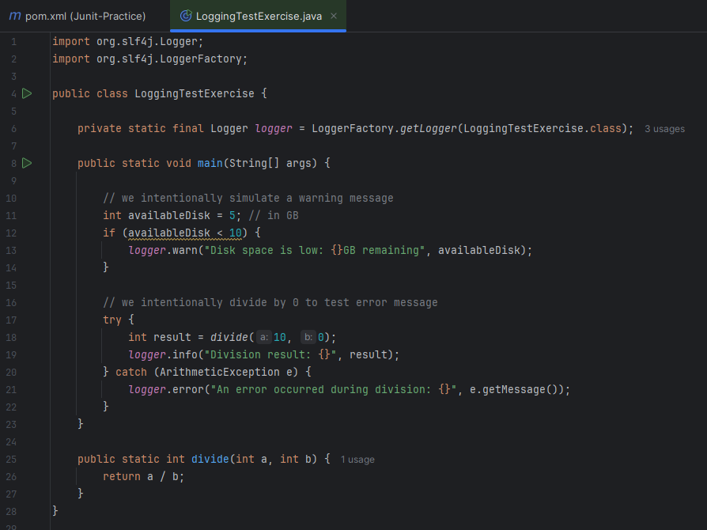

**OUTPUT :**

